CEG 4750/6750 (Information Security)
Homework #1

Question 1 (10 points)

List and briefly define categories of security services.
Answer: The categories of security services are listed and briefly defined below:
- Confidentiality: protects information from unauthorized disclosure.
- Integrity: ensures information is not altered without authorization.
- Availability: ensures systems and data are accessible when needed.
- Authentication: verifies the identity of users or systems.
- Non-repudiation: prevents a party from denying previous actions.
- Access Control: restricts access to resources based on policies.

Question 2 (10 points)

What are the two basic functions (methods) used in classical encryption algorithms?
Answer: The two basic functions (methods) used in classical encryption algorithms are:
- Substitution: replacing each letter or group of letters with another.
- Transposition/Permutation: rearranging the order of letters without changing them.

Question 3 (10 points)

What is the difference between a block cipher and a stream cipher?
Answer: The difference between a block cipher and a stream cipher are as follows:
- Block cipher: Encrypts data in fixed-size blocks (e.g., 64 or 128 bits).
- Stream cipher: Encrypts data one bit or byte at a time, typically using a keystream.

Question 4 (10 points).

Encrypt the message “attackhmsfleet” using Playfair Cipher with key =”security”. Use filler “x” and use “I” for the pair “I/J” in the table. Show your work.
Answer: To encrypt the message attackhmsfleet using the Playfair Cipher with the key security, we must first construct a 5×5 cipher matrix. The key is processed by removing duplicate letters of course and then filling in the remaining letters of the alphabet (combining I and J into one cell), and arranging them row by row. The resulting matrix is:
S E C U R
I T Y A B
D F G H K
L M N O P
Q V W X Z
The plaintext is divided into digraphs. If a pair contains the same letter, an x is inserted to break it, but here, attackhmsfleet splits cleanly into: at, ta, ck, hm, sf, le, et. Each digraph is encrypted using the Playfair rules, i.e.:
If both letters are in the same row, replace with letters to the right.
If both are in the same column, replace with letters below.
Otherwise, replace with letters in the same row but at the corners of the rectangle formed by the two letters. So by applying these rules: at becomes CU, ta becomes UC, ck becomes EP, hm becomes KL, sf becomes ED, le becomes MC, et (same row) becomes RI. Thus, the final ciphertext is CUUCEPKLEDMCRI.

Question 5 (10 points).

Using Vigenere cipher, encrypt the message “sendmoremoney” using the key “cipher”. Show your work.
Answer: For the Vigenere cipher encryption of sendmoremoney with the key cipher, we first repeat the key to match the message length:
So the key becomes: ciphercipherci. We then convert each letter to a numeric value (A=0, B=1, …, Z=25) and add the key’s value to the plaintext’s value modulo 26. i.e.:
Plaintext: s e n d m o r e m o n e y
Numerical: 18 4 13 3 12 14 17 4 12 14 13 4 24
Key (cipher…): 2 8 15 7 4 17 2 8 15 7 4 17 2
Sum (mod 26): 20 12 2 10 16 5 19 12 1 21 17 21 0
Now converting back to letters:
20 becomes U, 12 becomes M, 2 becomes C, 10 becomes K, 16 becomes Q, 5 becomes F, 19 becomes T, 12 becomes M, 1 becomes B, 21 becomes V, 17 becomes R, 21 becomes V, 0 becomes A. Hence, the resulting ciphertext is UMCKQFTMBVRVA.

Question 6 (10 points).

Lets make the question simple. Assume an input character only can be {0, 1,…, 11,12}; i.e., from ‘a’ to ‘m’ where ‘a’ is 0 and ‘m’ is 12. So it is modulo 13 rather than 26.
7 11
3 4
Encrypt the message “idea” using the Hill Cipher with the key

Show your calculation and result.

Hint: The plaintext block, and the ciphertext block can be represented as a column vector or a row vector.
Answer:
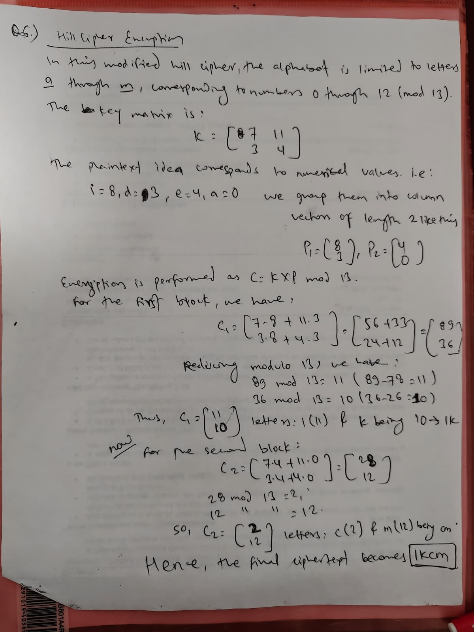

Question 7 (10 points) What are the two problems with one-time pad?
Answer: The one-time pad, while theoretically unbreakable if used correctly, suffers from two major practical problems. First, key distribution is highly impractical. Meaning, the key must be at least as long as the message and must be transmitted securely to the recipient before communication. In large scale or dynamic systems, this requires an immense logistical effort and secure channels that are often unavailable.
Second, key reuse vulnerability poses a severe risk. Meaning, if the same key is used to encrypt more than one message, the system becomes susceptible to cryptanalytic attacks. Specifically, an attacker can XOR two ciphertexts encrypted with the same key to eliminate the key and analyze the resulting combination of plaintexts, potentially revealing both messages. Thus, while theoretically secure, the one-time pad is often infeasible for real world use due to these operational constraints.

